**Mathematics**

• Count forwards & backward with positive & negative numbers through zero

• Count forwards/backwards in steps of powers of 10 for any given number up to 1000000

• Count up/down in thousandths

• Read Roman numerals to 1000

• Identify all multiples and factors, including finding all factor pairs

• Use known tables to derive other number facts

• Recall prime numbers up to 19

• Recognise Place Value of any number up to 1000000

• Round any number up to 1000000 to the nearest 10, 100, 1000, 10000 or 100000

• Round decimals with 2dp to nearest whole number & 1dp

• Add & subtract: Numbers with more than 4-digits using efficient written method

Numbers with up to 2dp

• Multiply 4-digits by 1-digit/ 2-digit

• Divide 4-digits by 1-digit

• Multiply & divide whole numbers & decimals by 10, 100 & 1000

• Add and subtract numbers mentally with increasing large numbers

• Use all four operations to solve word problems

• Recognise mixed numbers & fractions & convert from one to another

• Add and subtract fractions with the same denominator and multiples of the same number

• Read and write decimal numbers up to three decimal places

• Compare and order numbers with 3 decimal places

• Multiply proper fractions by whole numbers

• Recognise percent symbol and link with fraction and decimals of ½, ¼, 1/5, 2/5, 4/5 and those with a denominator of a multiple of 10 or 25

• Convert between different units of metric measure

• Measure and calculate perimeter and areas of simple shapes

• Estimate volume and capacity

• Identify 2-D and 3-D shapes

• Know, draw and compare angles

• Identify, describe and represent the position of a shape following reflection or translation

• Complete, read and interpret information in tables and graphs



**“Achievement for All”**

**End of Year Expectations**

**Year 5**

This booklet provides information for parents and carers about the end of year expectations for children in our school. These expectations have been identified as being the minimum requirements your child must meet in order to ensure continued progress throughout the following year.

All the objectives will be worked on throughout the year and will be the focus of direct teaching. Any extra support you can provide in helping your child to achieve these is greatly valued.

If you have any queries regarding the content of this booklet or want support in knowing how best to help your child, please talk to your child's teacher.

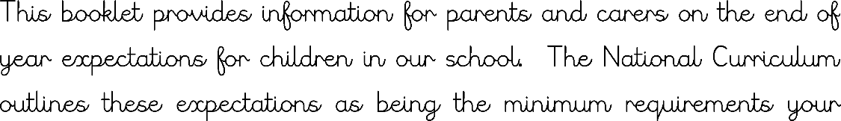

**Speaking and Listening**

• Give well-structured explanations

• Consider and evaluate different viewpoints

• Listen to others responsively in discussion and link own ideas clearly to others views, even when these views are different

**Writing**

• Plan, draft and write for a range of purposes

• Use organisational and presentational features

• Develop character, setting and atmosphere in narrative

• Add phrases to make sentences more precise and detailed

• Use range of sentence openers – judging the impact or effect needed

• Begin to adapt sentence structure to text type

• Evaluate and edit by proposing changes to vocabulary, grammar and punctuation

• Ensure correct use of tenses

• Proof-read for spelling and punctuation errors

• Use pronouns to avoid repetition

• Use brackets, dashes and commas

• Use commas to clarify meaning or avoid ambiguity

• Link clauses in sentences using a range of subordinating and coordinating conjunctions

• Link ideas across paragraphs using adverbials of time (e.g. later), place (e.g. nearby) and number (e.g. secondly)

• Perform own compositions

• Legible and fluent handwriting style

**Reading**

• Maintain positive attitudes to reading

• Read a broad range of genres and texts

• Discuss and recommend books to others

• Learn a wide range of poetry by heart showing understanding through intonation, volume and tone

•Summarise main points of an argument or discussion within their reading & make up own mind about issue/s

• Appreciate that people use bias in persuasive writing

• Distinguish between statements of fact and opinion

• Appreciate how two people may have a different view on the same event

• Use more than one source when carrying out research

• Create a set of notes to summarise what has been read

• Compare two texts

• Provide reasoned justifications for their view

• Draw inferences and justify with evidence from the text

• Vary voice for direct or indirect speech

• Predict what might happen next in the text

• Discuss and evaluate how authors use language and how it impacts the reader

**Spelling**

• Spell word endings accurately

• Spell common homophones accurately e.g. aisle, isle

• Spelling rules and statutory word list within Year 5 spelling curriculum