**Mathematics**

• Compare and order numbers up to 1000

• Read and write all numbers to 1000 in digits and words

• Find 10 or 100 more/less than a given number

• Count from 0 in multiples of 2, 3, 5, 4, 8, 10, 50 & 100

• Recall and use multiplication and division facts for 2, 3, 4, 5, 8 and 10 tables

• Recognise place value of any 3-digit number

• Add and subtract: 3-digit and single digit numbers (345+8) 3-digit numbers and multiples of 10 (682+50) 3-digit numbers and multiples of 100 (725 +300)

• Add and subtract numbers with up to 3-digits using efficient written method (column)

• Use inverse to check

• Multiply 2-digit by 1-digit (37x4)

• Count up/down in tenths

• Compare and order fractions with same denominator

• +/- fractions with same denominator

• Know pairs of fractions that total 1

• Tell time using 12 and 24 hour clocks; and using Roman numerals

• Know number of days in each month and year

• Draw 2-D/Make 3-D shapes

•Identify and use right angles, and horizontal, vertical, perpendicular and parallel lines

• Measure perimeter of a 2-D shape

•Interpret and present data using bar charts, pictograms and tables



**“Achievement for All”**

**End of Year Expectations**

**Year 3**

This booklet provides information for parents and carers about the end of year expectations for children in our school. These expectations have been identified as being the minimum requirements your child must meet in order to ensure continued progress throughout the following year.

All the objectives will be worked on throughout the year and will be the focus of direct teaching. Any extra support you can provide in helping your child to achieve these is greatly valued.

If you have any queries regarding the content of this booklet or want support in knowing how best to help your child, please talk to your child's teacher.

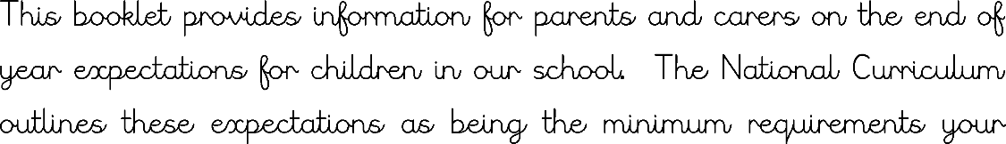

**Reading**

• Comment on the way characters relate to one another

• Know which words are essential in a sentence to retain meaning

• Draw inferences such as inferring characters’ feelings, thoughts and motives from/for their actions

• Recognise how commas are used to give more meaning

• Recognise: plurals, pronouns and how they are used, collective nouns and adverbs

• Can explain the difference that adjectives and verbs make to a sentence

• Use dictionaries to check meanings

•Prepare poems and plays to perform

**Spelling**

• Use prefixes and suffixes correctly

• Use a dictionary to check spelling

• Spelling rules and statutory word list within Year 3 spelling curriculum

**Speaking and Listening**

• Develop ideas and feelings through sustained talk

• Show good awareness of the listener

• Use a different style, tone and volume when speaking to a larger audience

• Listen carefully and make relevant comments in response to what has been said • Suggest different ideas related to a specific problem

• Summarise the main issues associated with a talk

**Writing**

• Use conjunctions (when, so, before, after, while, because)

• Use time connectives (e.g. then, next, soon)

• Use prepositions (e.g. before, after, during, in, because of)

• Experiment with adjectives to create impact

• Correctly use verbs in 1st, 2nd and 3rd person

• Use the present perfect form of verbs, e.g. He has gone out to play.

• Correctly use a range of punctuation including inverted commas for direct speech

• Group ideas into paragraphs around a theme

• Write under headings and sub-headings

• Neat, legible, joined handwriting with letters of consistent size