**Mathematics**

• Count to and across 100, forwards and backwards from any number

• Read and write numbers to 20 in digits and words

• Read and write numbers to 100 in digits • Say 1 more and1 less than numbers to 100

• Count in multiples of 1, 2, 5 and 10

• Know bonds to 10 by heart • Use bonds and subtraction facts to 20

• Add and subtract 1 digit and 2 digit numbers to 20, including zero

• Add any three 1-digit numbers with a total up to 20

• Solve simple multiplication and division with apparatus

• Recognise half and quarter of an object, shape or quantity

• Sequence events in order

• Know months of the year in order

• Use language of day, week, month and year

• Know o’clock and half past using analogue clock

• Recognise and name common 2D shapes, e.g. square, rectangle, circle and triangle

• Recognise and name common 3D shapes, e.g. cube, cuboid, sphere and pyramid

• Describe whole, half, quarter and three quarter turns



**“Achievement for All”**

**End of Year Expectations**

**Year 1**

This booklet provides information for parents and carers about the end of year expectations for children in our school. These expectations have been identified as being the minimum requirements your child must meet in order to ensure continued progress throughout the following year.

All the objectives will be worked on throughout the year and will be the focus of direct teaching. Any extra support you can provide in helping your child to achieve these is greatly valued.

If you have any queries regarding the content of this booklet or want support in knowing how best to help your child, please talk to your child's teacher.

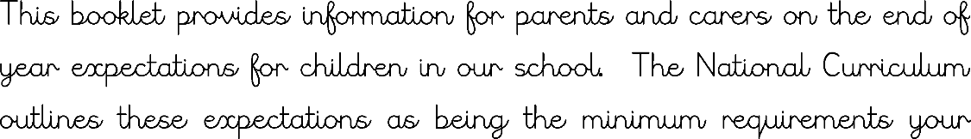

**Reading**

• Read for pleasure and relate reading to own experiences

• Re-read to correct

• Re-tell with considerable accuracy

• Discuss significance of title and events

• Make simple predictions on basis of what has been read

• Read with pace and expression, i.e. pause at full stops and raise voice for a question

• Know difference between fiction and non-fiction texts

• Learn some simple rhymes and poems by heart

• Read Phase 4 and Phase 5 tricky words

• Be secure at Phase 5 phonics

**Spelling**

• Words using Phase 5 phonemes

• Tricky words from Phase 4 and Phase 5

• The days of the week

• Spell Year 1 common exception words

**Speaking and Listening**

• Talk clearly and loudly enough to be understood by others

• Listen attentively to others and respond appropriately

• Take turns when speaking without interrupting others

**Writing**

• Write sentences that start with a capital letter and end with a full stop

• Use ‘and’ to join ideas

• In writing, show evidence of full stops, question marks or exclamation marks

• Use capital letters for names of people, places and days of the week, and the personal pronoun ‘I’

• Write clearly sequenced sentences

• Correct formation of capital and lower case – starting and finishing in the right place

• Correct formation of digits