**Mathematics**

• Compare & order numbers up to 10000000

• Identify common factors, common multiples & prime numbers

• Round any whole number to a required degree of accuracy

• Use negative numbers in context and calculate intervals across zero

• Multiply and divide 4-digit by 2-digit

• Perform mental calculations, including mixed operations, with larger numbers

• Add & subtract fractions with different denominators & mixed numbers

• Multiply simple pairs of proper fractions, writing the answer in the simplest form

• Divide proper fractions by whole numbers

• Identify the value of digits to three decimal places

• Calculate % of whole number

• Identify common factors, common multiples and prime numbers

• Solve multi-step problems in context

• Use estimation to check answers to calculations

• Express missing number problems algebraically

• Use, read, write and convert between standard units, converting measurements of length, mass, volume and time.

• Calculate, estimate and compare volume of cubes and cuboids

• Use properties of regular and irregular polygons to reduce related facts and to find missing lengths and angles

• Draw 2D shapes using given dimensions and angles

• Recognise, build and describe 3-D shapes, including nets

• Illustrate and name parts of circle, including radius, diameter and circumference

• Identify, describe and represent the position of a shape following a reflection or translation

• Calculate area and perimeters of shape

• Draw and translate simple shapes and reflect them in the axes

• Describe positions on a full coordinate grid (all four quadrants)

• Interpret and construct pie charts and line graphs

• Complete, read and interpret graphs and tables

• Calculate and interpret the mean as an average



**“Achievement for All”**

**End of Year Expectations**

**Year 6**

This booklet provides information for parents and carers about the end of year expectations for children in our school. These expectations have been identified as being the minimum requirements your child must meet in order to ensure continued progress throughout the following year.

All the objectives will be worked on throughout the year and will be the focus of direct teaching. Any extra support you can provide in helping your child to achieve these is greatly valued.

If you have any queries regarding the content of this booklet or want support in knowing how best to help your child, please talk to your child's teacher.

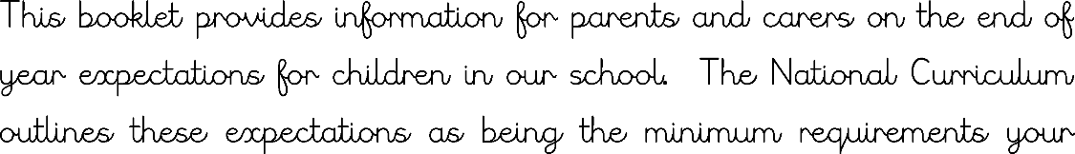

**Speaking and Listening**

• Use questions to build knowledge

• Articulate arguments and opinions

• Use spoken language to speculate, hypothesise and explore

• Use appropriate register and language

**Writing**

• Plan, draft and write for a range of purposes

• Use organisational and presentational features

• Develop character, setting and atmosphere in narrative

• Use range of sentence openers – judging the impact or effect needed

• Begin to adapt sentence structure to text type

• Evaluate and edit by proposing changes to vocabulary, grammar and punctuation

• Ensure correct use of tenses

• Proof-read for spelling and punctuation errors

• Use pronouns to avoid repetition

• Use brackets, dashes and commas

• Use commas to clarify meaning or avoid ambiguity

• Link clauses in sentences using a range of subordinating and coordinating conjunctions

• Link ideas across paragraphs using adverbials of time (e.g. later), place (e.g. nearby) and number (e.g. secondly)

• Use subordinate clauses to write complex sentences

• Use passive voice where appropriate

• Use expanded noun phrases to convey complicated information concisely (e.g. The fact that it was raining meant the end of sports day.)

• Evidence of sentence structure and layout matched to requirements of text type

• Use semi-colon, colon and dash to mark the boundary between independent clauses

• Use correct punctuation of bullet points, hyphens to avoid ambiguity and a full range of punctuation matched to requirements of text type

• Use wide range of devices to build cohesion within and across paragraphs

• Use paragraphs to signal change in time, scene, action, mood or person

• Legible, fluent and personal handwriting style

**Reading**

• Read a broad range of genres and texts

• Discuss and recommend books to others

• Learn a wide range of poetry by heart showing understanding through intonation, volume and tone

• Compare two texts

• Support inference with evidence

• Skim and scan to aid note-taking

• Create a set of notes to summarise what has been read

• Provide reasoned justifications for their view

• Distinguish between statements of fact and opinion

• Summarise main points of an argument or discussion within their reading and make up own mind about issue/s

• Appreciate how two people may have a different view on the same event

• Draw inferences and justify with evidence from the text

• Vary voice for direct or indirect speech

• Predict what might happen next in the text

• Discuss and evaluate how authors use language and how it impacts the reader

• Identify and discuss how language, structure and ideas contribute to meaning

• Appreciate how a set of sentences has been arranged to create maximum effect

**Spelling**

• Use and spell word endings accurately

• Use hyphen accurately

• Spelling rules and statutory word list within Year 6 spelling curriculum