**Mathematics**

• Compare and order numbers up to 100 using > < and =, and say 10 more/less than any number to 100

• Read and write all numbers to 100 in digits and words

• Recall and use +/- facts to 20

• Derive and use related facts to 100

• Count in multiples of 2, 3, 5 and 10 from any number up to 100

• Recall and use multiplication and division facts for 2, 5 and 10 tables to solve x and ÷ equations

• Recognise place value of any 2-digit number

• Add and subtract: 2-digit and 1-digit numbers (43+6) 2-digit and 10s numbers (45-20) Two 2-digit numbers (13+34) Three 1-digit numbers (4+5+7)

• Recognise and use inverse (14+5=19, so 19- 5=14, 3x5=15, so 15 ÷ 3=5)

• Recognise, find, name and write 1/3; 1/4; 2/4; 3/4

• Recognise equivalence of simple fractions (2/4 = ½)

• Use symbols for £ and p and add/subtract amounts of money

• Know and use standard measures, e.g. cm and g

• Tell time to five minutes, including quarter past/to

• Describe properties of 2D shape including the number of sides and lines of symmetry



**“Achievement for All”**

**End of Year Expectations**

**Year 2**

This booklet provides information for parents and carers about the end of year expectations for children in our school. These expectations have been identified as being the minimum requirements your child must meet in order to ensure continued progress throughout the following year.

All the objectives will be worked on throughout the year and will be the focus of direct teaching. Any extra support you can provide in helping your child to achieve these is greatly valued.

If you have any queries regarding the content of this booklet or want support in knowing how best to help your child, please talk to your child's teacher.

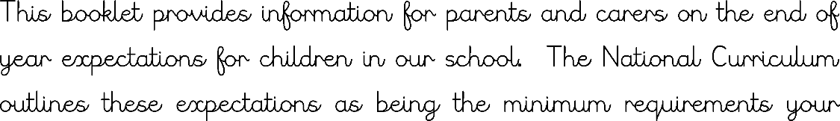

**Reading**

• Read a range of texts with fluency and expression

• Discuss and express views about fiction, nonfiction and poetry

• Continue to build up a repertoire of poems learnt by heart

• Comment on plot, setting and characters in familiar and unfamiliar stories

• Re-tell familiar stories

• Ask and answer simple questions, and begin to make inferences and predictions

• Comment on the structure of the text

• Use commas, question marks and exclamation marks to vary expression

• Recognise inverted commas (speech marks) and contractions (can’t, don’t)

• Identify past and present tense

• Use content and index to locate information

• Be secure at Phase 6 Phonics

• Read common exception words

**Spelling**

•Spell common Year 2 exception words

•Add suffixes to spell longer words including – ment, –ness, –ful, –less, –ly

• Spelling patterns from the Year 2 spelling curriculum

**Speaking and Listening**

• Talk about experiences giving detail and using descriptive language

• Think of a range of questions to ask a visitor

• Recognise the need to take equal turns in a group situation and not interrupt others

• Listen and build on what a previous speaker has said

**Writing**

• Write different kinds of sentence: statement, question, exclamation and command

• Use expanded noun phrases to add description and specification (for example the blue butterfly)

• Write using subordination (when, if, that, because) and co-ordination (and, but, or)

• Correct and consistent use of present tense and past tense

• Correct and consistent use of a wider range of punctuation: capital letters, full stops, questions marks, exclamation marks and commas in a list

• Be able to use an apostrophe for omission of letters (wasn’t)

• Write under headings

• Handwriting to be joined