**Mathematics**

• Count reliably to 20

• Count a number of objects by pointing to/moving each one as they count

• Recognise numbers to 20

• Order numbers 1 – 20

• Say 1 more and 1 less than numbers to 20

• Add and subtract two single digit numbers

• Form all digits 0-9 correctly

• Know the names of the days of the week in order

• Begin to recognise and name common 2D shapes, e.g. square, rectangle, circle and triangle

• Begin to recognise and name some 3D shapes, e.g. cube, sphere, cylinder, cone



**“Achievement for All”**

**End of Year Expectations**

**Early Years Foundation Stage**

This booklet provides information for parents and carers about the end of year expectations for children in our school. These expectations have been identified as being the minimum requirements your child must meet in order to ensure continued progress throughout the following year.

All the objectives will be worked on throughout the year and will be the focus of direct teaching. Any extra support you can provide in helping your child to achieve these is greatly valued.

If you have any queries regarding the content of this booklet or want support in knowing how best to help your child, please talk to your child's teacher.

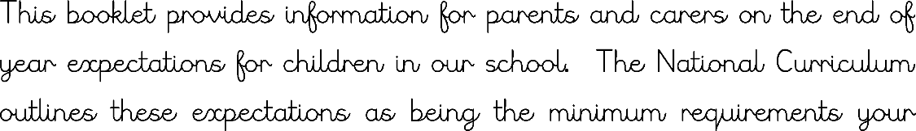

**Reading**

• Look at books and listen to stories

• Use phonic knowledge to decode regular words

• Be secure at Phase 4 phonics

• Read Phase 2, Phase 3 and Phase 4 tricky words

• Identify rhymes and alliteration

• Join in with rhyming patterns

• Read and understand simple sentences

• Demonstrate understanding when talking with others about what they have read

• Make basic predictions

• Identify the start and end of a sentence

• Know the alphabet and link letter names to the sound they make

• Know the difference between a capital and lower case letter

• Learn some simple rhymes and poems by heart

**Speaking and Listening**

• Use complete sentences to explain or describe things

• Listen carefully to what is being said and repeat this if needed

• Know not to interrupt when someone else is saying something

• Stand up in front of others and re-tell something that has happened to them

**Writing**

• Use phonic knowledge to write simple sentences which can be read by themselves and others

• Write name (correct capital and lower case)

• Use capital letters and full stops to demarcate sentences

• Write clearly demarcated sentences

• Use a correct pencil grip

• Correct formation of all letters