**Mathematics**

• Count backwards through zero to include negative numbers

• Compare and order numbers beyond 1000

• Compare and order numbers with 2 decimal places

• Read Roman numerals to 100 (I to C)

• Find 1000 more/less than a given number

• Count in multiples of 6, 7, 9, 25 & 1000

• Recall & use multiplication & division facts for all tables to 12 x 12

• Recognise Place Value of any 4-digit number

• Round any number to the nearest 10, 100 or 1000

• Round decimals with 1dp to nearest whole number

• Add & subtract: Numbers with up to 4-digits using efficient written method

Numbers with up to 1dp

• Multiply: 2-digit by 1-digit 3-digit by 1-digit

• Divide: 3-digit by 1-digit

• Count up/down in hundredths

• Write equivalent fractions

• +/- fractions with same denominator

• Identify simple equivalent fractions

• Add and subtract fractions with common denominators

• Recognise and write decimal equivalents of any number of tenths or hundredths

• Recognise, round and write decimal equivalents

• Read, write & convert time between analogue & digital, 12 & 24 hour clocks

• Compare 2-D shapes, including quadrilaterals and triangles

• Find the area and perimeter of a shape

• Estimate and calculate measurements

• Identify properties of angles

• Introduce simple translations and identify symmetry

• Use first quadrant coordinates

• Use bar charts, pictograms and line graphs

• Estimate, compare and calculate different measurements, including money in pounds and pence

• Solve number and real-life problems



**“Achievement for All”**

**End of Year Expectations**

**Year 4**

This booklet provides information for parents and carers about the end of year expectations for children in our school. These expectations have been identified as being the minimum requirements your child must meet in order to ensure continued progress throughout the following year.

All the objectives will be worked on throughout the year and will be the focus of direct teaching. Any extra support you can provide in helping your child to achieve these is greatly valued.

If you have any queries regarding the content of this booklet or want support in knowing how best to help your child, please talk to your child's teacher.

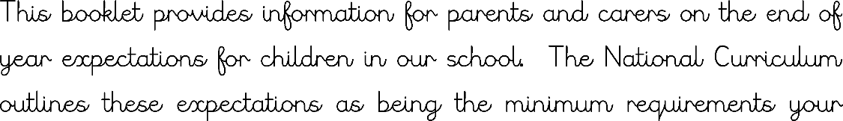

**Reading**

• Read a range of texts for enjoyment

• Re-tell some stories orally with expression

• Give a personal point of view on a text

• Identify themes and conventions in a wide range of books

• Discuss words and phrases that capture the reader’s interest and imagination

• Recognise and perform different forms of poetry

• Explain a text with confidence

• Justify inferences with evidence, predicting what might happen from details stated or implied

• Identify how sentence type can be changed by altering word order, tenses, adding/deleting words or amending punctuation

• Skim and scan to locate information and/or answer a question

**Spelling**

• Use prefixes and suffixes correctly

• Spell common homophones

• Spelling rules and statutory word list within Year 4 spelling curriculum

**Speaking and Listening**

• Articulate and justify opinions

• Speak with clear diction so that the audience can hear what is being said

• Maintain and monitor the interest of the listener

• Participate in discussions, taking turns and listening to what others have to say

**Writing**

• Plan, draft and write in a range of genres

• Proof-read for spelling and punctuation errors

• Evaluate and edit own and others writing

• Read aloud own work, to a group or the whole class using appropriate intonation and tone

• Build a varied and rich range of vocabulary

• Use adjectival phrases (e.g. biting cold wind)

• Vary sentence structure, using different openers

• Appropriate choice of noun or pronoun

• Apostrophe for singular & plural possession

• Comma after fronted adverbial (e.g. Later that day, I heard some good news.)

• Use commas to mark clauses

• Use connectives to link paragraphs around a theme

• Legible, joined handwriting of consistent quality